Chapter 1 PySpark SQL
Create a SQL table from a dataframe
A dataframe can be used to create a temporary table. A temporary table is one that will not exist after the session ends. Spark documentation also refers to this type of table as a SQL temporary view. In the documentation this is referred to as to register the dataframe as a SQL temporary view. This command is called on the dataframe itself, and creates a table if it does not already exist, replacing it with the current data from the dataframe if it does already exist.
- Load csv data from the file trainsched.txt into a dataframe stored in a variable named df. Create a temporary table from df. Call the table "table1".
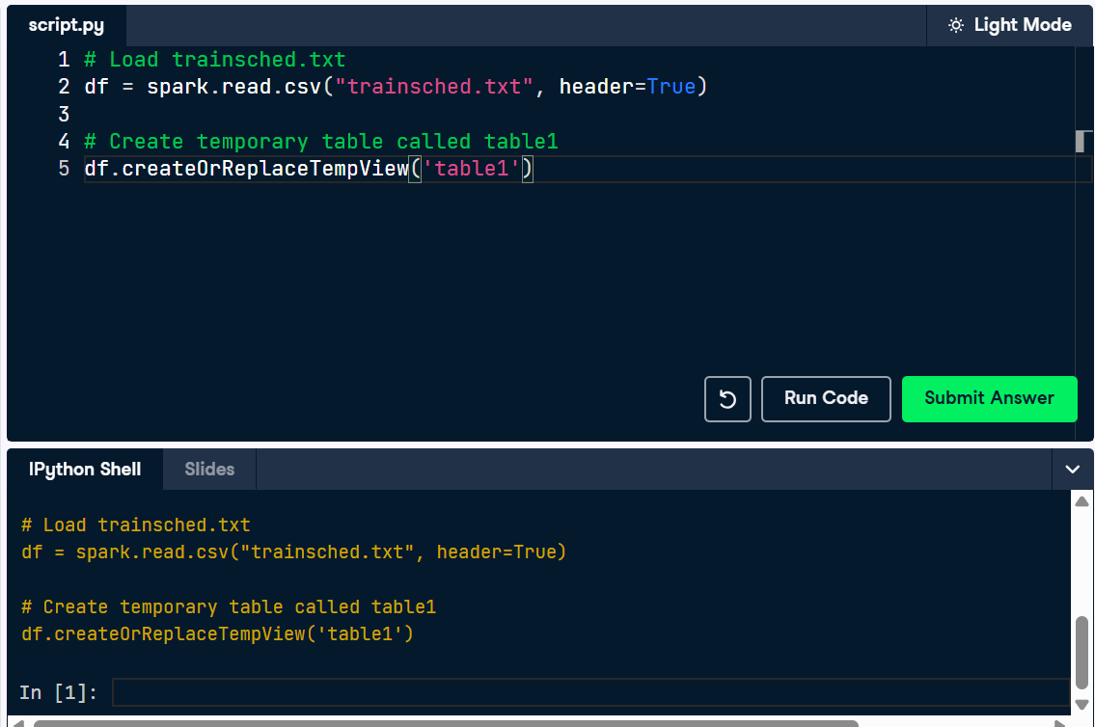

Determine the column names of a table
The video lesson showed how to run an SQL query. It also showed how to inspect the column names of a Spark table using SQL. This is important to know because in practice relational tables are typically provided without additional documentation giving the table schema.
Don't hesitate to refer to the slides available at the right of the console if you forget how something was done in the video.
- Use a DESCRIBE query to determine the names and types of the columns in the table schedule.
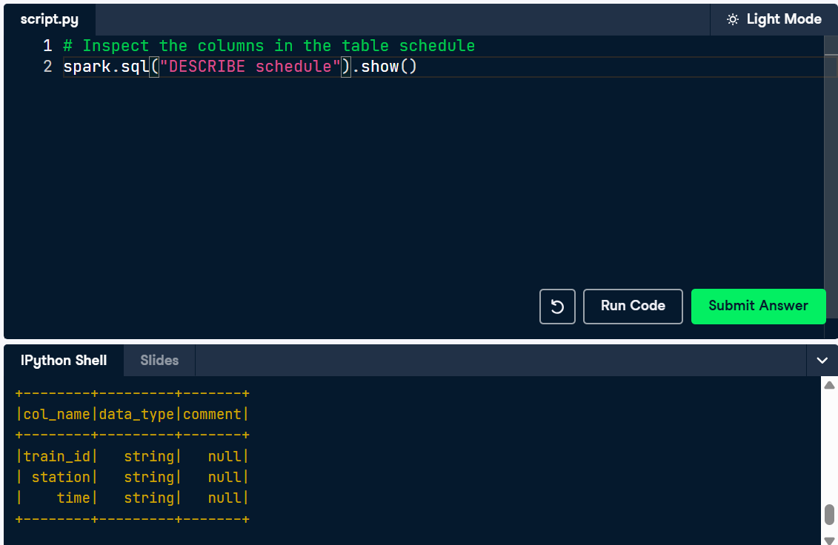

Running sums using window function SQL
A window function is like an aggregate function, except that it gives an output for every row in the dataset instead of a single row per group.
You can do aggregation along with window functions. A running sum using a window function is simpler than what is required using joins. The query duration can also be much faster.
A table called schedule, having columns train_id, station, time, and diff_min is provided for you. The diff_min column gives the elapsed time between the current station and the next station on the line.
- Run a query that adds an additional column to the records in this dataset called running_total. The column running_total SUM()s the difference between station time given by the diff_min column.
- Run the query and display the result.
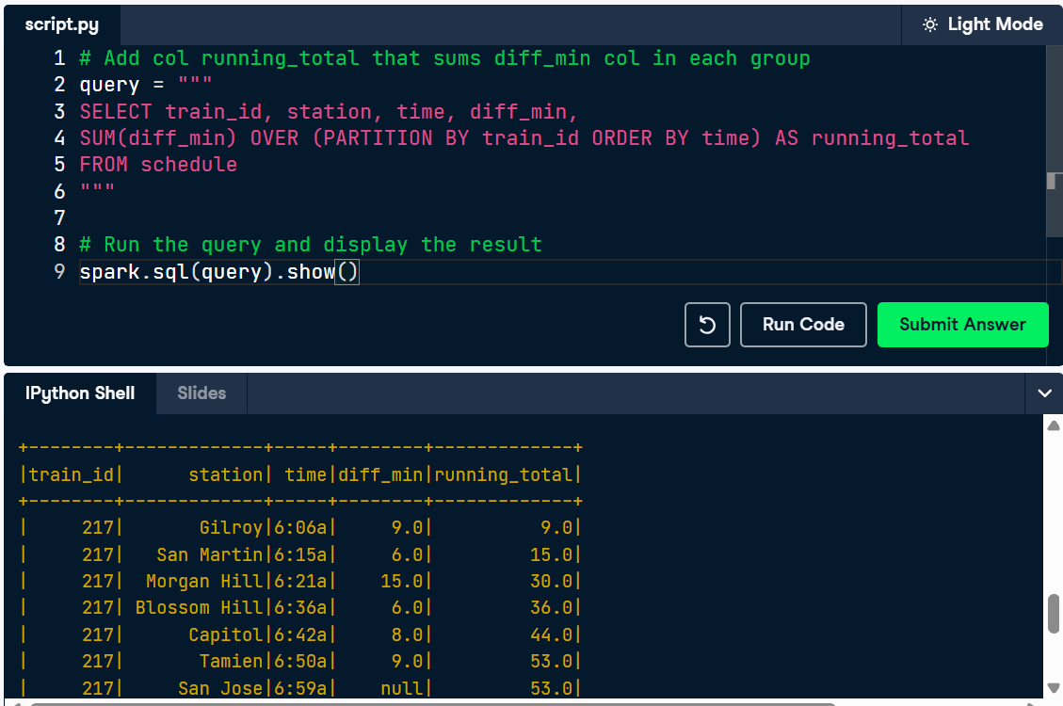
Fix the broken query
This query runs correctly, but gives an incorrect result in one of the rows because of an omission in the OVER clause. Can you locate the bug? Can you modify the query to make it give a reasonable result?
- Provide the row number of the erroneous row as an integer.
- Provide the clause (as a string) that when added to the OVER clause fixes the problem.
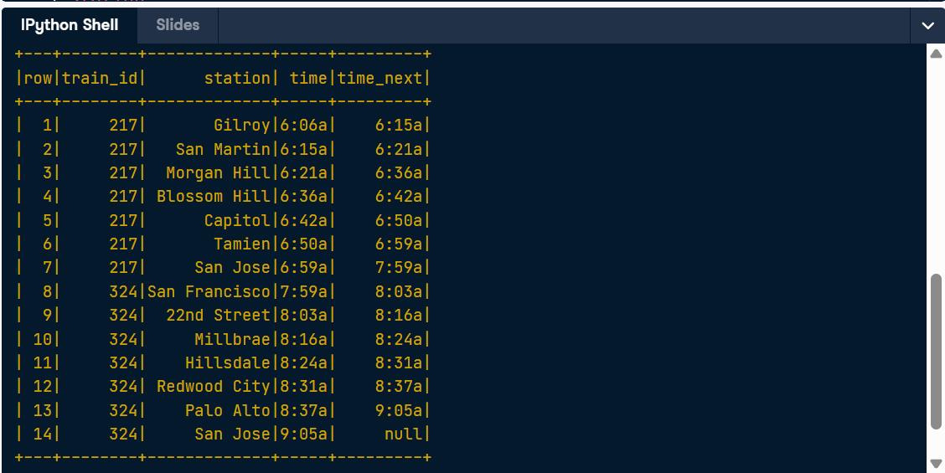
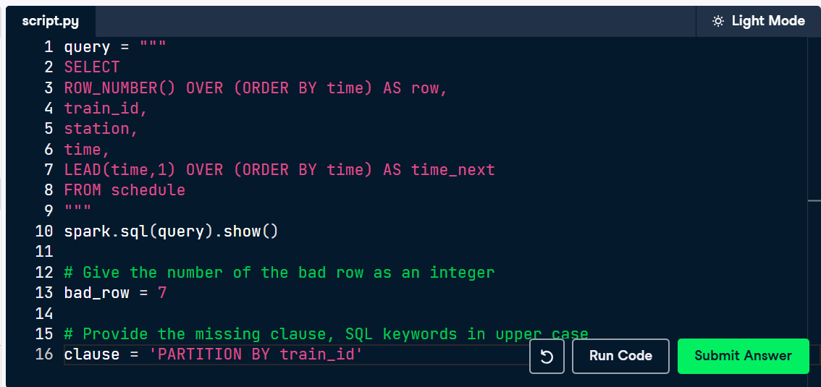

Aggregation, step by step
Whether to use dot notation or SQL is a personal preference. However, as demonstrated in the video exercise, there are cases where SQL is simpler. Also as demonstrated in the video lesson, there are also cases where the dot notation gives a counterintuitive result, such as when a second aggregation on a column clobbers a prior aggregation on that column. As mentioned in the video, the basic syntax of agg in pyspark is only able to do a single aggregation on each column at a time.
The following exercises calculate the time of the first departure for each train line.
The first two queries match. However, the second two do not. Can you determine why?
- Fill in the blanks to get the first pair of commands to display the identical result.
- The fourth result, named result, is a naive attempt at replicating the previous line. However, it is counter-intuitively different. How? Fill in the blank to print the name of the second column of result.
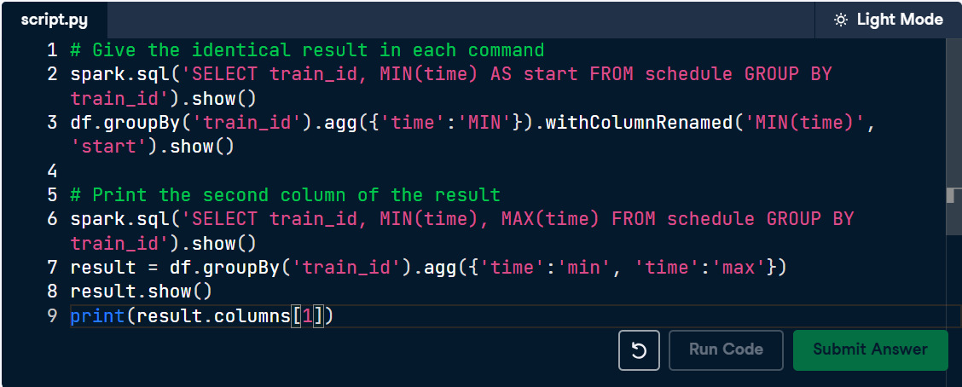
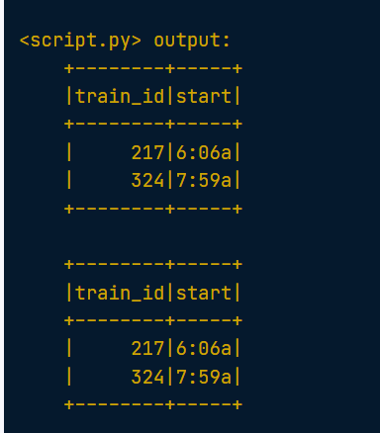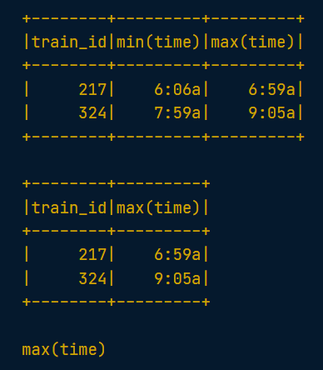

Aggregating the same column twice
There are cases where dot notation can be more cumbersome than SQL. This exercise calculates the first and last times for each train line. The following code does this using dot notation.
from pyspark.sql.functions import min, max, col
expr = [min(col("time")).alias('start'), max(col("time")).alias('end')]
dot_df = df.groupBy("train_id").agg(*expr)
dot_df.show()

+--------+-----+-----+
|train_id|start| end|
+--------+-----+-----+
| 217|6:06a|6:59a|
| 324|7:59a|9:05a|
+--------+-----+-----+
Your mission is to achieve this same result using a SQL query. The dataframe df has been registered as a table named schedule.
- Write a SQL query that gives an identical result to the dot notation query.
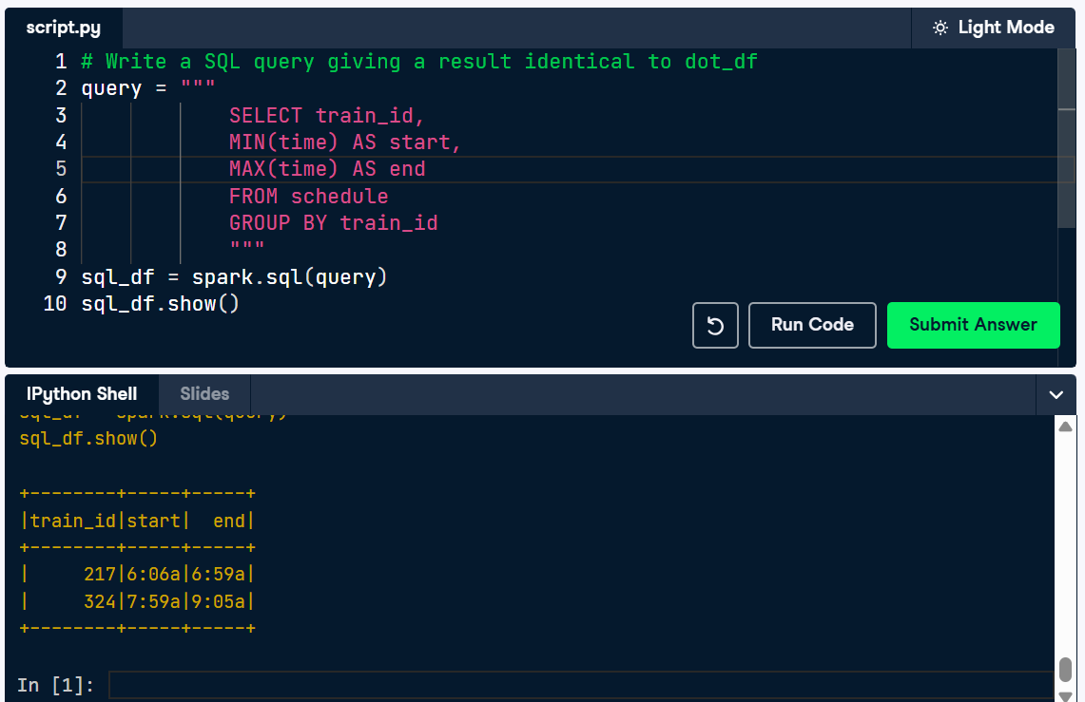

Aggregate dot SQL
The following code uses SQL to set the value of a dataframe called df.
df = spark.sql("""
SELECT *,
LEAD(time,1) OVER(PARTITION BY train_id ORDER BY time) AS time_next
FROM schedule
""")
The LEAD clause has an equivalent function in pyspark.sql.functions. The PARTITION BY, and ORDER BY clauses each have an equivalent dot notation function that is called on the Window object. The following imports are available: from pyspark.sql import Window, from pyspark.sql.functions import lead

- Create a dataframe called dot_df that contains the identical result as df, using dot notation instead of SQL.

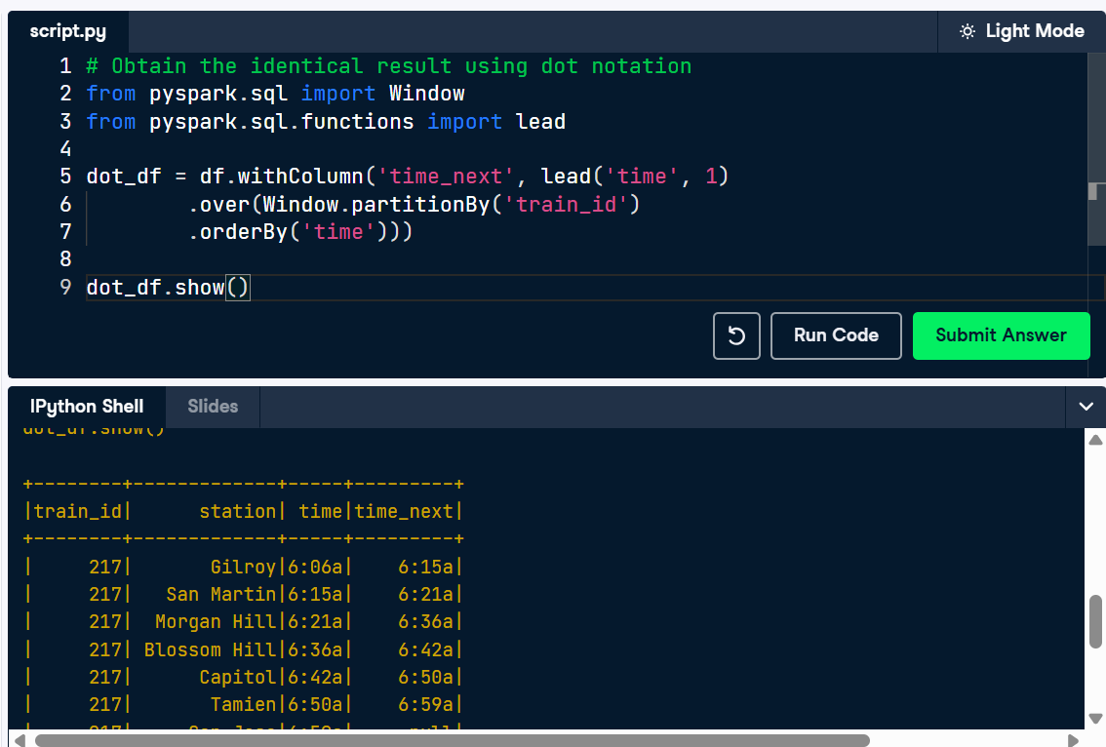

Convert window function from dot notation to SQL
We are going to add a column to a train schedule so that each row contains the number of minutes for the train to reach its next stop.
- We have a dataframe df where df.columns == ['train_id', 'station', 'time'].
- df is registered as a SQL table named schedule.
- The following window function query uses dot notation. It gives a new dataframe dot_df.

window = Window.partitionBy('train_id').orderBy('time')
dot_df = df.withColumn('diff_min',
(unix_timestamp(lead('time', 1).over(window),'H:m')
- unix_timestamp('time', 'H:m'))/60)

Note the use of the unix_timestamp function, which is equivalent to the UNIX_TIMESTAMP SQL function.
Please be aware of the scaffolding in the sample code. Formatting the answer according to the scaffolding will ensure that your submitted answer is not erroneously rejected due to a formatting issue.
- Create a SQL query to obtain an identical result to dot_df. Please format the query according to the scaffolding (i.e., the placeholder underscores _____) .

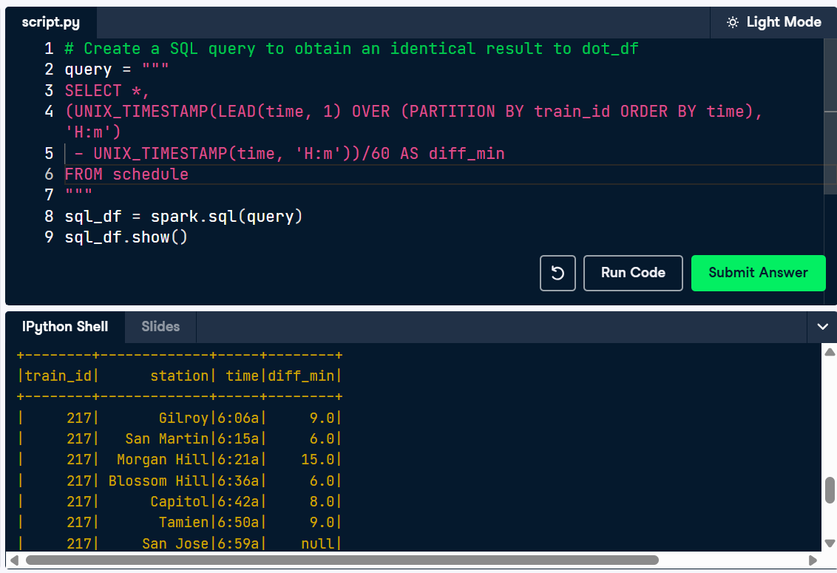
Chapter 2: Using Window Function SQL for Natural Language Processing
Loading a dataframe from a parquet file
A dataframe file called sherlock_sentences.parquet is available in your workspace. Each row of this dataframe contains a single clause. Each clause is a sequence of words that is separated from other clauses by punctuation, such as periods, quotes, and other natural language delimiters that signify a sentence or sentence fragment. Your mission, if you choose to accept it, is to load this file.
- Load sherlock_sentences.parquet. Filter on "id > 70", and show the first 5 rows.
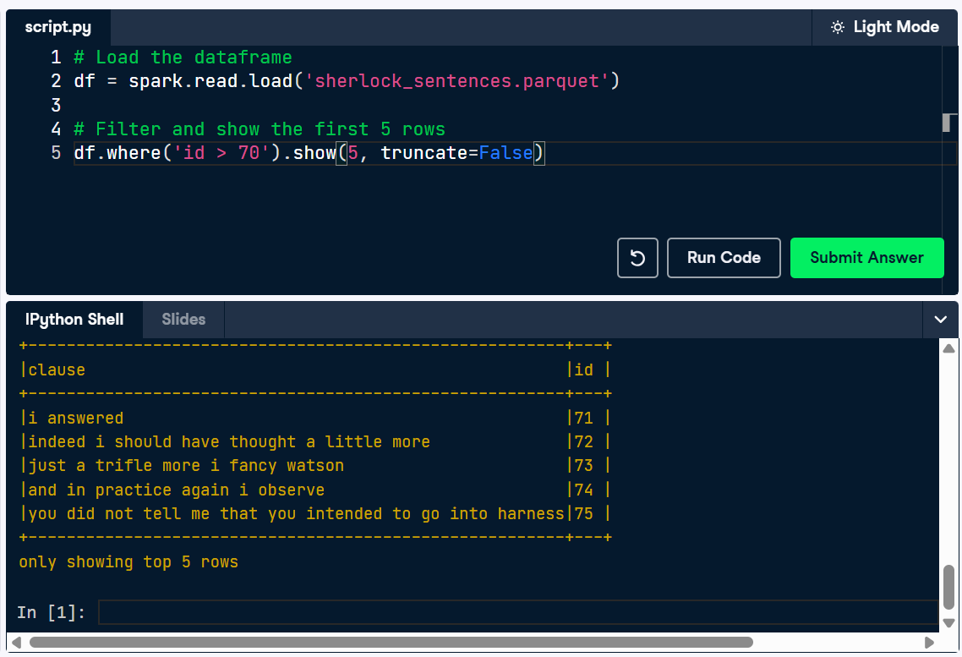

Split and explode a text column
A dataframe clauses_df with 100 rows is provided. It has a column clause and a row id. Each clause is a string containing one or more words separated by spaces.
- Split the clause column into a column called words, containing an array of individual words. Explode the words column into a column called word. Count the resulting number of rows.

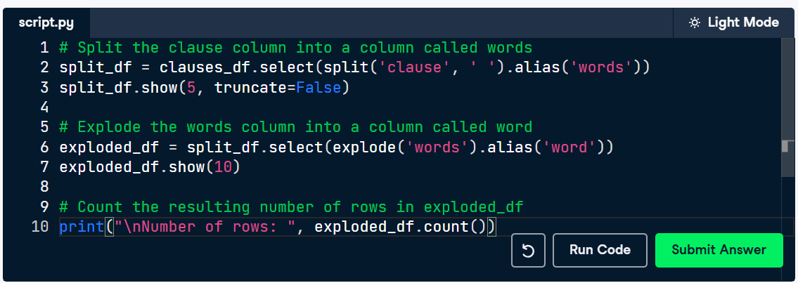
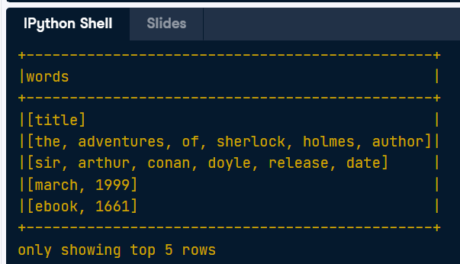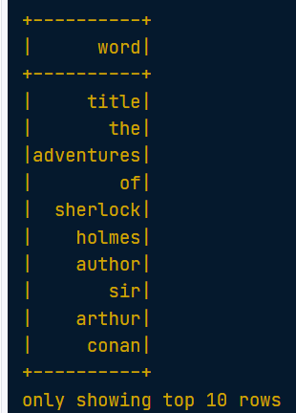

Creating context window feature data
The moving window technique is useful for machine learning algorithms models that use context window feature data.
A table text having columns id, word, part, title is available in your workspace. It contains chapters 9, 10, 11 and 12 of the Sherlock Holmes book. The words are already processed and organized into one word per row. Each word has a unique integer index provided by the column id. The id column is lower for words that appear earlier in the text and greater for words appearing later in the text.
The first 10 rows of the dataset for chapter 12 are printed to the console as Table1. The first ten rows of the desired result, constrained to show part 12 (Chapter 12) are printed to the console as Table2. In Table2, the "given" word for the row is provided in column w3. Columns w1 and w2 give the two words immediately prior to the given word. Columns w4 and w5 give the two words immediately after the given word.
Note how w1 and w2 are null for the first row. This is because there are not any words prior to w3 (here, "xii") that are within part 12.
Don't hesitate to refer to the slides available at the right of the console if you forget how something was done in the video.
- Get the word for each row, along with the previous two words and the subsequent two words.
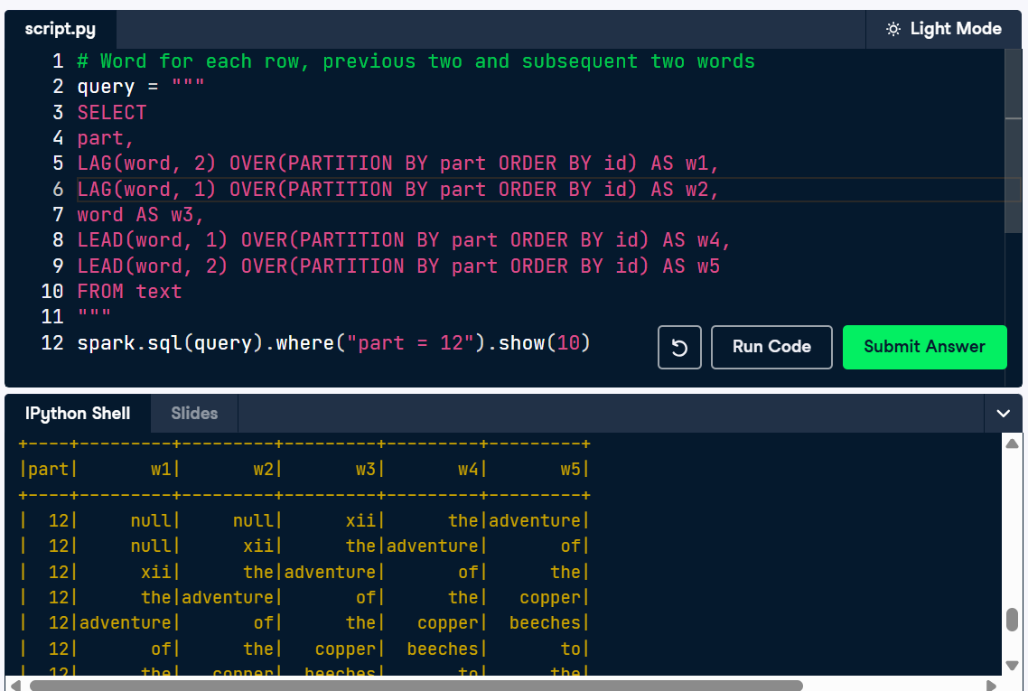

Repartitioning the data
A dataframe text_df exists, having columns id, word, and chapter. The first 5 rows of text_df are printed to the console.
You can determine that there are 12 chapters by the following:
text_df.select('chapter')\
.distinct()\
.sort('chapter')\
.show(truncate=False)
The result of this command is printed to the console as Table 1.
The dataframe text_df is currently in a single partition. Suppose that you know that the upcoming processing steps are going to be grouping the data on chapters. Processing the data will be most efficient if each chapter stays within a single machine. To avoid unnecessary shuffling of the data from one machine to another, let's repartition the dataframe into one partition per chapter, using the repartition and getNumPartitions commands taught in the first video lesson to this chapter.
Don't hesitate to refer to the slides available at the right of the console if you forget how something was done in the video.
- Repartition the text_df into 12 partitions, with each chapter in its own partition. Display the number of partitions in the new dataframe.
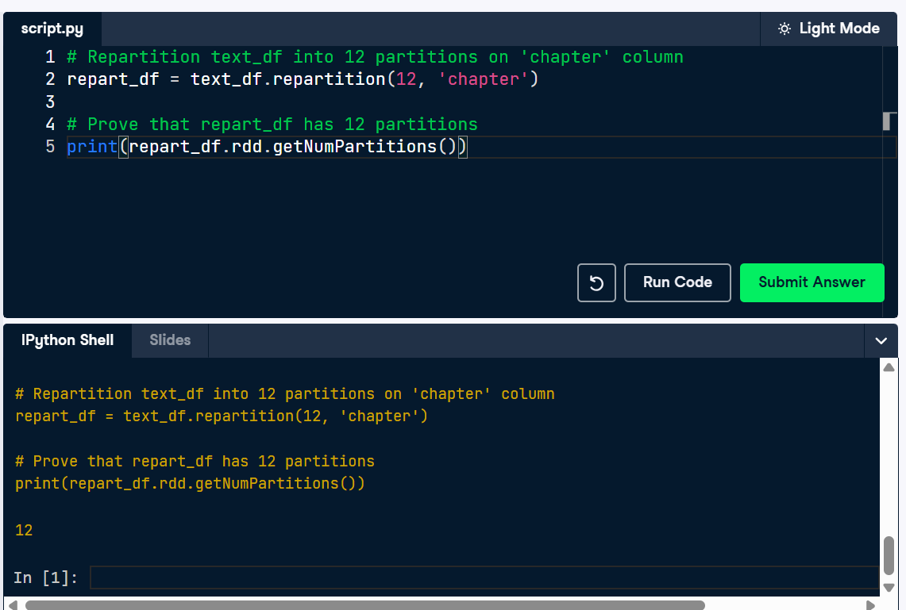

Finding common word sequences
Previously we saw how to create a query that finds word sequences of length three ("3-tuples"). We used that query as a subquery in a traditional SQL query to find the most common 3-tuples in the text document. You will now perform a similar task to find the most common 5-tuples.
DataFrame text_df is available. It contains the first five chapters of the Sherlock Holmes text. It has columns: word, id, part, title. The id column is an integer such that a word that comes later in the document has a larger id than a word that comes before it. The part column separates the data into chapters. The DataFrame text_df is also registered as temporary table called text. Our objective is to create a dataset where each row corresponds to a 5-tuple, having a count indicating how many times the tuple occurred in the dataset.
- Create a query query that finds the 10 most common 5-tuples in the dataset.

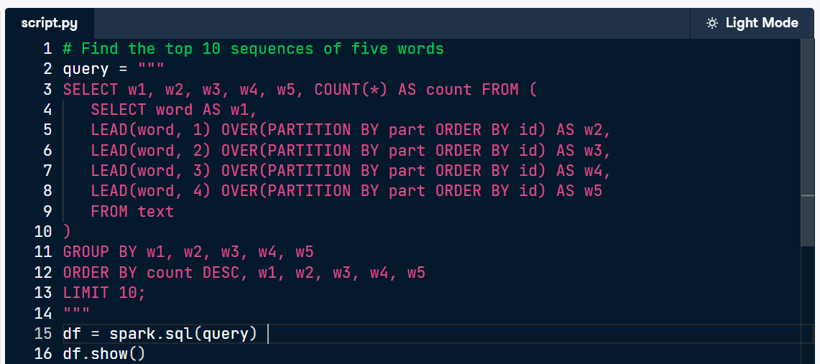
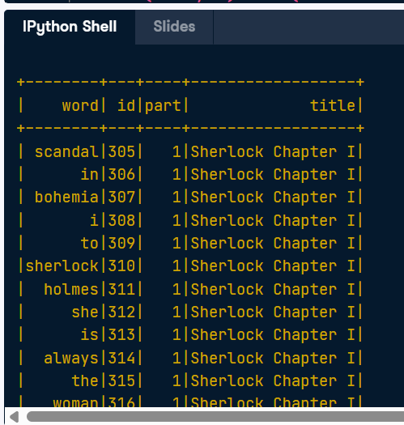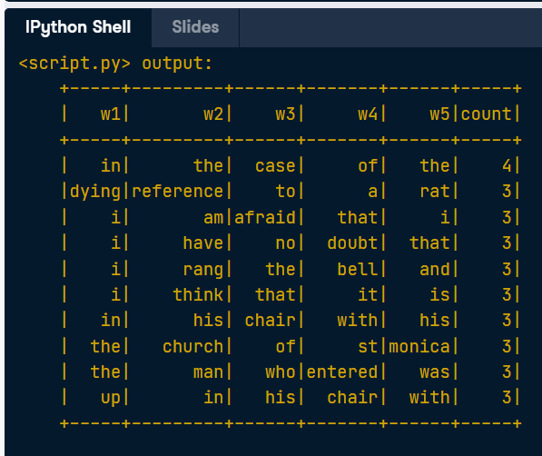
Nota de solución: Poner w1, w2, w3, w4, w5 después de count DESC sirve como un criterio de desempate para garantizar que los resultados de la consulta sean siempre idénticos y predecibles.
Si solo usas ORDER BY count DESC, Spark ordenará las secuencias de palabras de mayor a menor frecuencia. Sin embargo, si observas los resultados en tu pantalla, notarás que hay múltiples secuencias de 5 palabras que tienen exactamente el mismo número de apariciones (por ejemplo, varias tienen un count de 3 y otras de 2).
Cuando ocurre un empate en el conteo y no hay más criterios de ordenamiento, el motor de base de datos puede devolver esos registros empatados en cualquier orden aleatorio.

Unique 5-tuples in sorted order
A previous lesson taught an operation that eliminates duplicates, fetching unique records. In a previous exercise you obtained common 5-tuples. We will combine these two capabilities to find the unique 5-tuples, sorted alphabetically in descending order.
The table text contains the first four chapters of the Sherlock Holmes text. It has the following columns: word, id, and part.
- Retrieve the last ten unique 5-tuples sorted alphabetically in descending order.
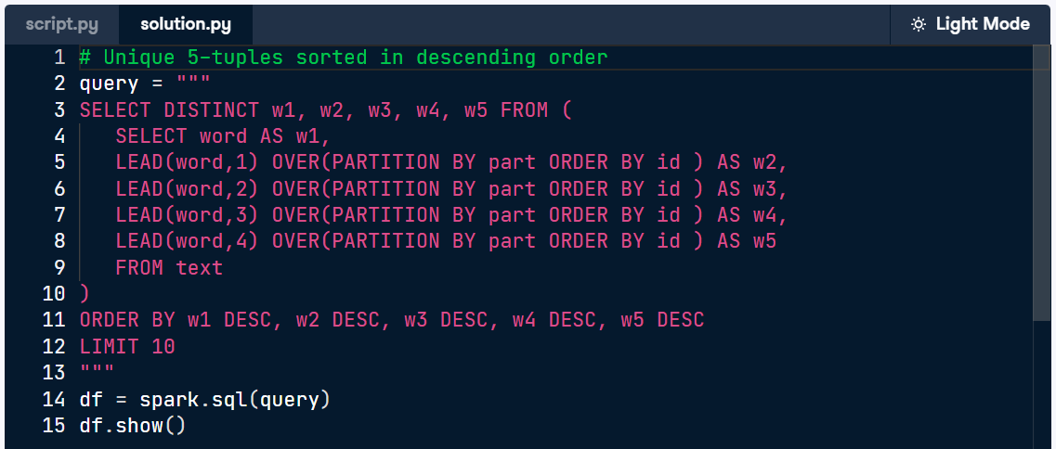
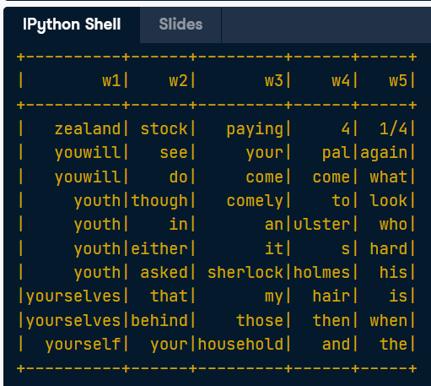
Nota de solución: No, DISTINCT no opera solo sobre w1. En SQL, cuando usas la cláusula SELECT DISTINCT, esta se aplica a la combinación completa de todas las columnas que hayas puesto en la selección.
En tu código SELECT DISTINCT w1, w2, w3, w4, w5, Spark evalúa la fila entera como un solo bloque (es decir, la secuencia completa de las 5 palabras).
Solo se eliminará un registro si las 5 columnas son exactamente idénticas a las de otro registro.

Most frequent 3-tuples per chapter
We will now use a query as a subquery in a larger query. Spark SQL supports advanced features of SQL. Previously you learned how to find the most common word sequences over an entire book having 12 chapters. Now you will obtain the most frequent 3-tuple for each of the 12 chapters. You will do this using a window function to retrieve the top row per group.
There is a table having columns word, id, chapter.
- The chapter column corresponds to the number of a chapter.
- The word column corresponds to a single word in the document.
- The id column corresponds to the word position in the document.

We also have the following query:
subquery = """
SELECT chapter, w1, w2, w3, COUNT(*) as count
FROM
(
SELECT
chapter,
word AS w1,
LEAD(word, 1) OVER(PARTITION BY chapter ORDER BY id ) AS w2,
LEAD(word, 2) OVER(PARTITION BY chapter ORDER BY id ) AS w3
FROM text
)
GROUP BY chapter, w1, w2, w3
ORDER BY chapter, count DESC
"""
spark.sql(subquery).show(5)
+-------+---+-----+----+-----+
|chapter| w1| w2| w3|count|
+-------+---+-----+----+-----+
| 1| up| to| the| 6|
| 1|one| of| the| 6|
| 1| in|front| of| 5|
| 1| up| and|down| 5|
| 1| it| was| a| 5|
+-------+---+-----+----+-----+
only showing top 5 rows

From this table you can determine that the first row of the desired result will be:
+-------+---+-----+----+-----+
|chapter| w1| w2| w3|count|
+-------+---+-----+----+-----+
| 1| up| to| the| 6|
+-------+---+-----+----+-----+

Your task is to use subquery as a subquery in a larger query to obtain the most frequent 3-tuple per chapter. The desired result will have the same schema, but having one row per chapter. Use ROW_NUMBER() to obtain the row number per row per chapter.

- Get the most frequent 3-tuple per chapter.
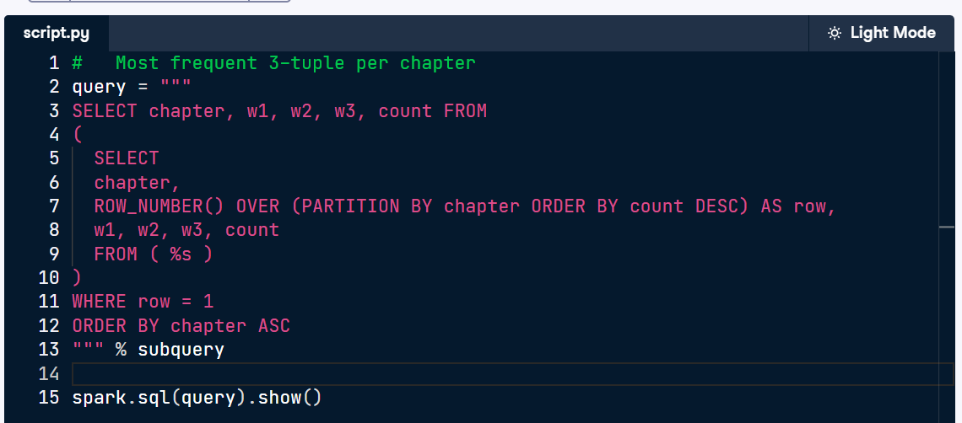
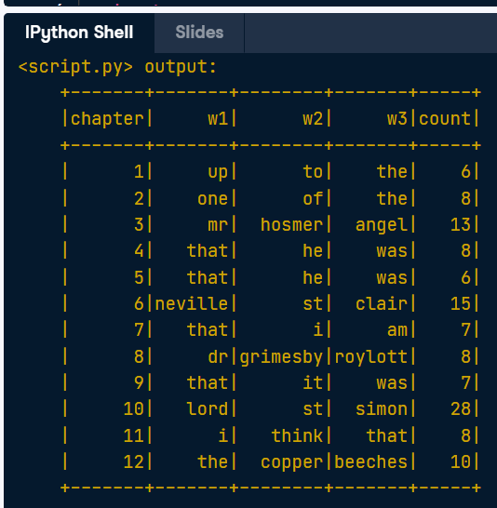
Nota de solución: La expresión FROM (%s) y % subquery combinan una técnica de programación en Python con una estructura de bases de datos en SQL. Aquí tienes cómo funcionan juntas:
- %s y % subquery (Marcador de posición en Python): En Python, %s actúa como un espacio en blanco o marcador de posición dentro del texto de la variable query. El operador % subquery al final de las comillas le indica a Python que tome el texto almacenado previamente en la variable subquery y lo inserte exactamente donde está el %s. Es una forma dinámica de concatenar o inyectar texto sin tener que copiar y pegar todo el código de la primera consulta.

Chapter 3: Caching, Logging, and the Spark UI
Practicing caching: part 1
In the next few exercises, you'll experiment with different ways of caching two DataFrames.
A dataframe df1 is loaded from a csv file. Several processing steps are performed on it. As df1 is to be used more than once, it is a candidate for caching.
A second dataframe df2 is created by performing additional compute-intensive steps on df1. It is also a candidate for caching.
Because df2 depends on df1 the question arises: is it better to cache df1, or to cache df2?
In this exercise, we'll try caching df1. Note the amount of time that each action takes. We'll be comparing these in the next exercise.
- Cache df1 only. Run a first action on df1 and repeat it, then run an action df2 and repeat it. This has been done for you. Confirm whether or not df1 is cached.
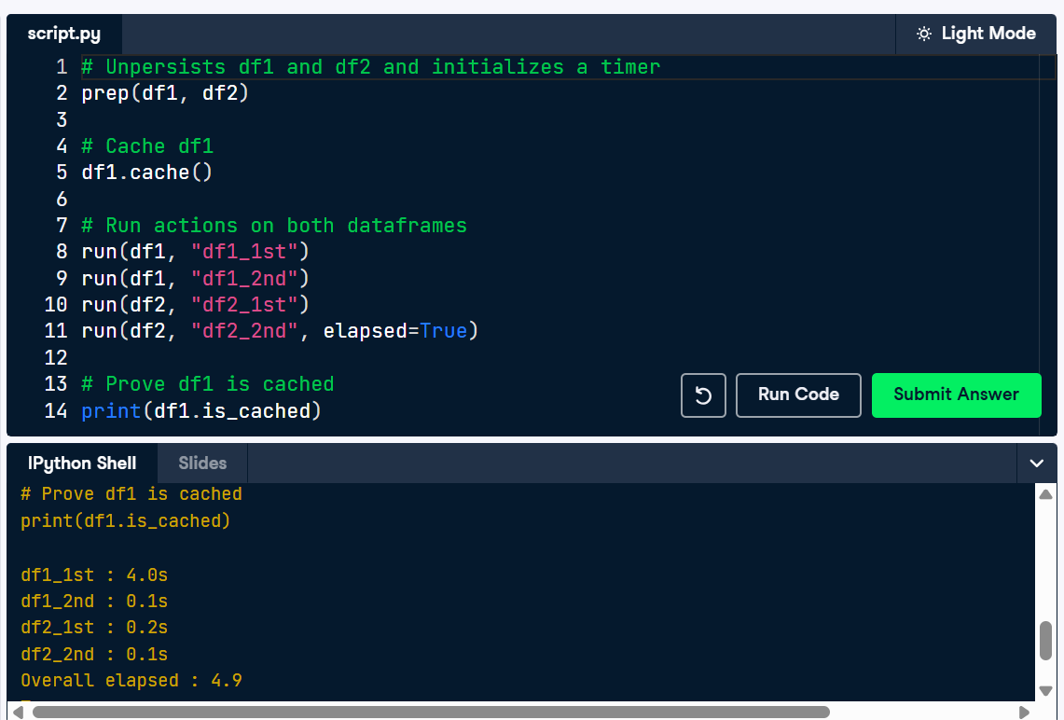
Practicing caching: the SQL
Previously, we examined two DataFrames: df1 and df2 (which is created from df1). We tried caching df1, but not df2. In this exercise, we'll examine the effects of caching df2, but not df1.
Once again, note the amount of time that each action takes. We'll be comparing these in the next exercise. Which tasks are sped up? Which are slowed down?

- Cache df2, but not df1. Run a first action on df1 and repeat it, then run an action df2 and repeat it. This has been done for you.
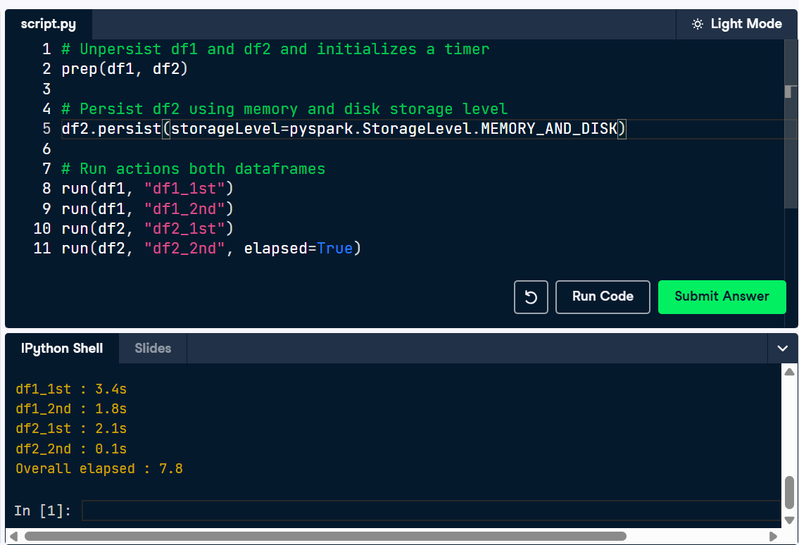

Caching and uncaching tables
In the lesson we learned that tables can be cached. Whereas a dataframe is cached using a cache or persist operation, a table is cached using a cacheTable operation.
A table called table1 is available.
- List the tables with the listTables() method. Cache table1 and confirm that it is cached. Uncache table1 and confirm that it is uncached.
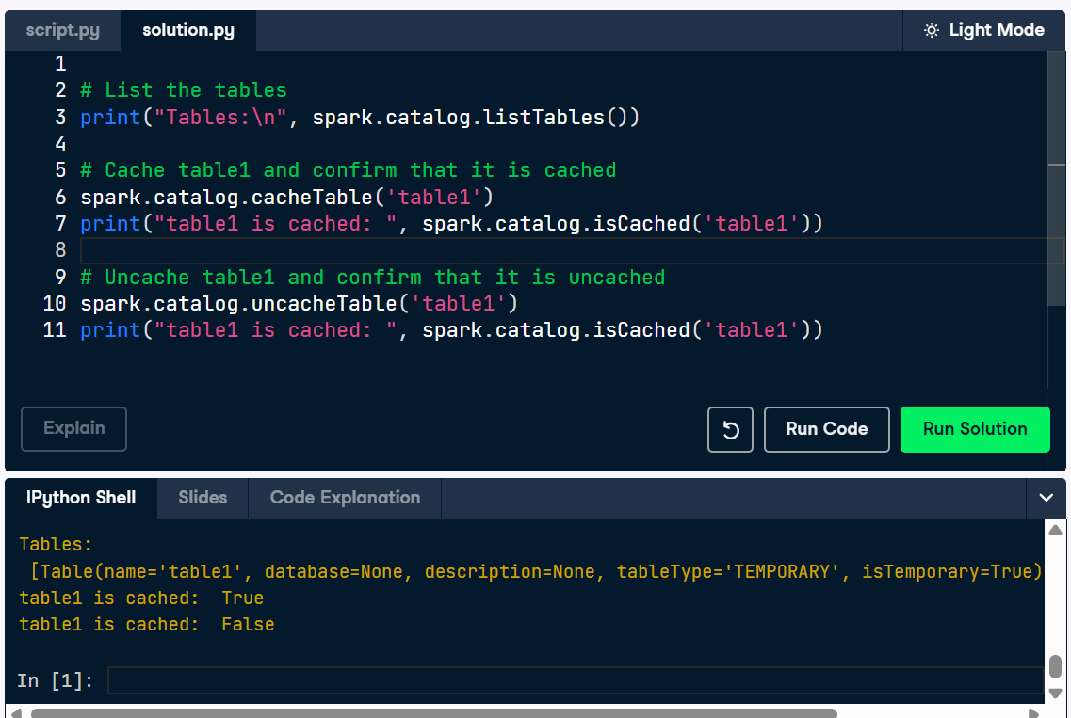

SPARK UI STORAGE TABS
Question
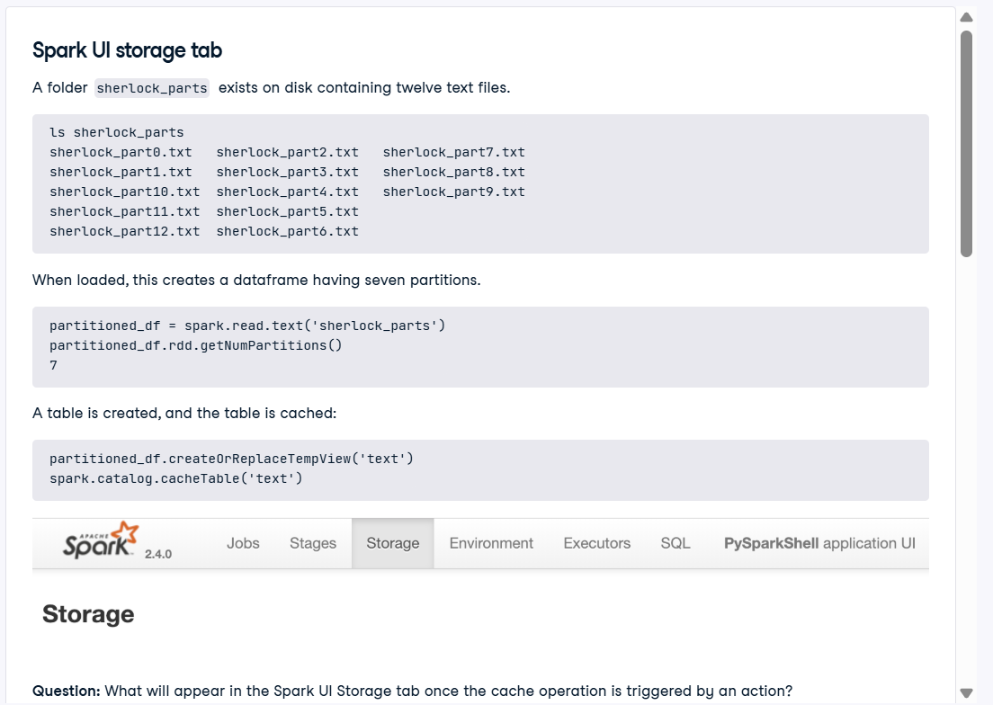
Answer:
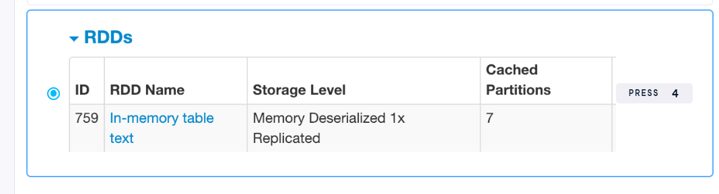

Inspecting cache in the SPARK UI
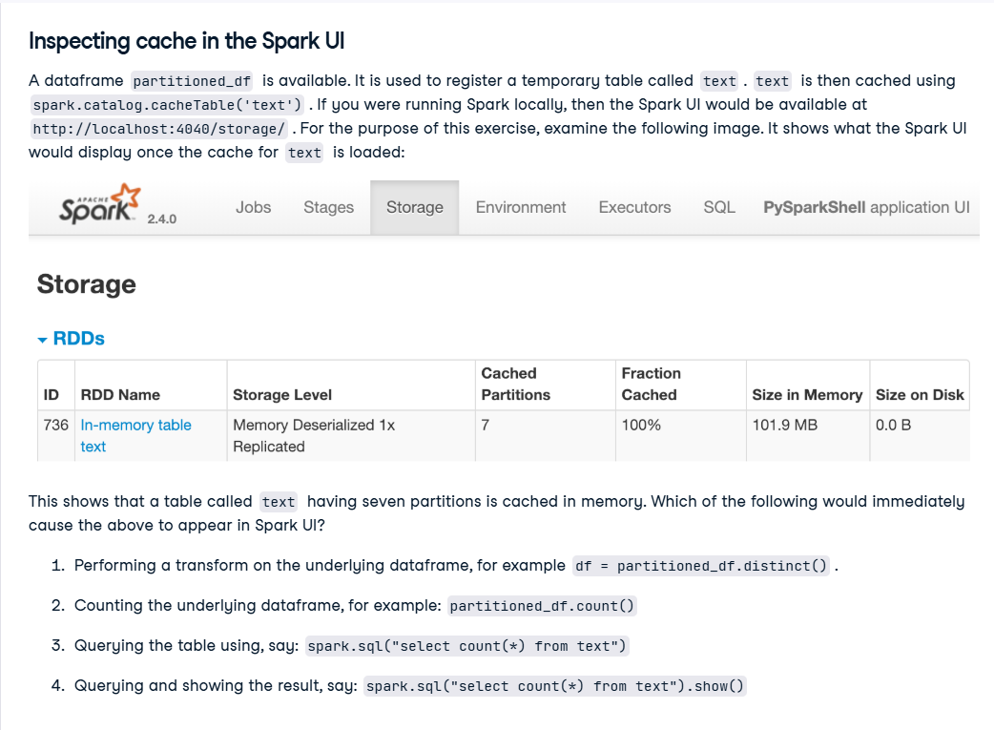
Answer: 2 and 4: Those have an action to trigger the cache load.

Practice logging
The following code is executed on startup:
import logging
logging.basicConfig(stream=sys.stdout, level=logging.DEBUG, format='%(levelname)s - %(message)s')
- Log columns of text_df as debug message.
- Log whether table1 is cached as info message.
- Log first row of text_df as warning message.
- Log selected columns of text_df as error message.
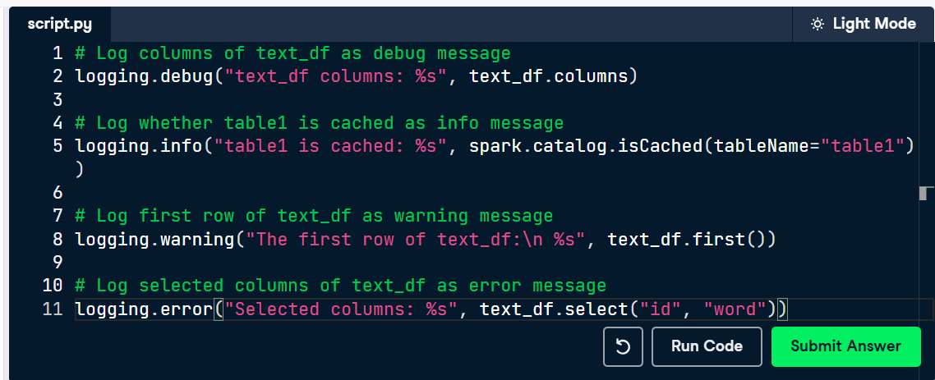
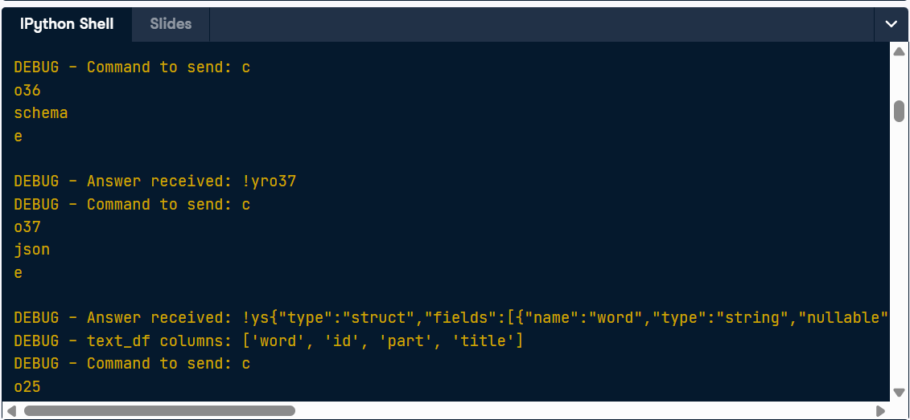

Practice logging 2
The following code is executed on startup:
import logging
logging.basicConfig(stream=sys.stdout, level=logging.DEBUG,
format='%(levelname)s - %(message)s')
In the lesson we learned that Spark operations that trigger an action must be logged with care to avoid stealth loss of compute resources. You will now practice identifying logging statements that trigger an action on a dataframe or table.
A dataframe text_df is available. This dataframe is registered as a table called table1.
- Several log statements are provided. All of them are initially commented out. Uncomment the five statements that do not trigger an action on text_df.
Nota para solución:
Para saber cuáles comandos NO disparan una acción en Spark, debes fijarte si el método es una Transformación/Metadato o una Acción. Spark funciona con "evaluación perezosa" (lazy evaluation), lo que significa que no procesa ningún dato hasta que se le obliga explícitamente a hacerlo.
Aquí tienes la regla clave para diferenciarlos en tu ejercicio:
1. Las que NO disparan la ejecución (Debes descomentarlas) Son comandos que solo leen la estructura de la tabla (metadatos) o que solo "preparan" una consulta para el futuro (transformaciones) devolviendo un DataFrame, pero sin procesar la información real.
- Ejemplos en tu código:
  - text_df.columns: Solo lee la lista de los nombres de las columnas, no toca los datos.
  - spark.catalog.isCached(...): Solo le pregunta al sistema si la tabla está guardada en memoria.
  - text_df.select("id", "word"): Es una transformación. Prepara la consulta para seleccionar esas dos columnas, pero no ejecuta la búsqueda aún.
  - spark.sql("SELECT * FROM table1 limit 1"): Aunque es una consulta SQL, al no tener un comando de acción pegado al final, solo se queda en la fase de preparación.
2. Las que SÍ disparan la ejecución (Déjalas comentadas) Son las Acciones. Estos comandos obligan a Spark a encender los motores, leer los datos reales de los discos y traer el resultado final de vuelta a la pantalla.
- Ejemplos en tu código:
  - text_df.first(): Obliga a Spark a buscar y devolver la primera fila real de la tabla.
  - ...spark.sql("show tables").collect(): El método .collect() es una acción fuerte que obliga a extraer todos los resultados y traerlos a la memoria principal.
  - Cualquier línea que termine en .count(), .show(), .collect() o .first().
Para resolver tu ejercicio, simplemente busca y descomenta las 5 líneas que no terminan pidiendo extraer datos reales (evita las que tengan .first(), .collect() o similares).
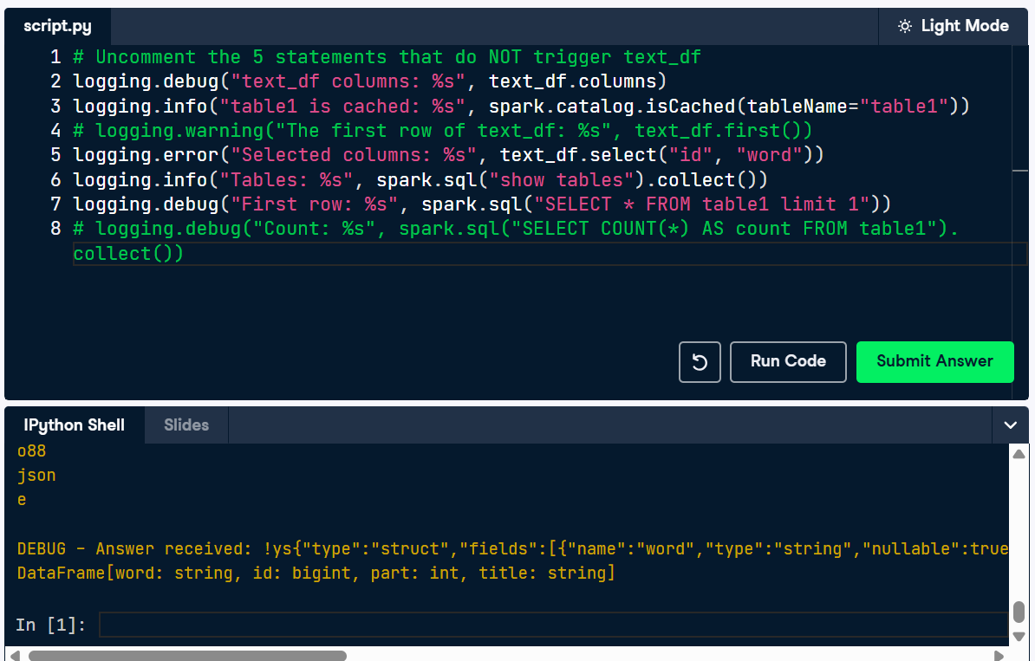
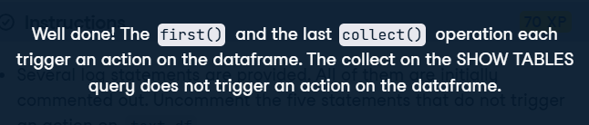

Practice query plans
A dataframe text_df is available. This dataframe is registered as a table called table1.
- Run explain on text_df. Run explain on a SQL query that does a "SELECT COUNT(*) as count" on table1. Run explain on a SQL query that counts the number of unique words in table1.
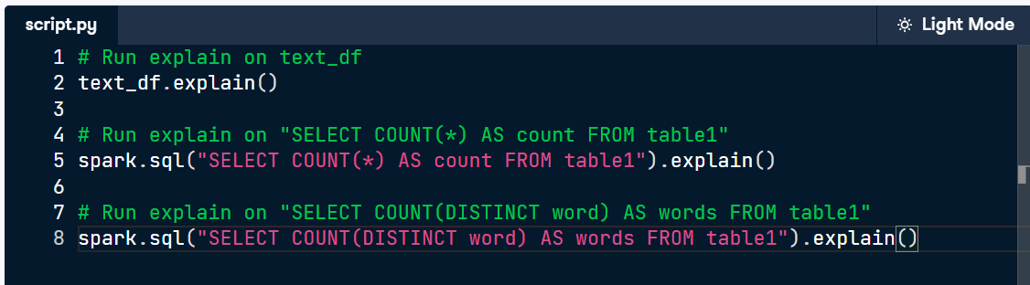
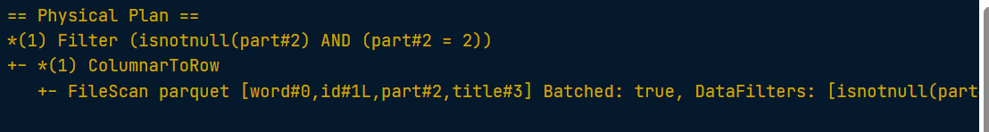
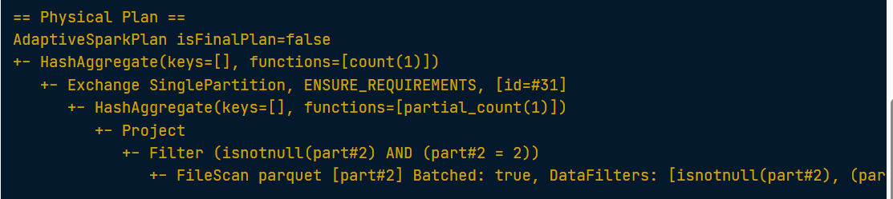
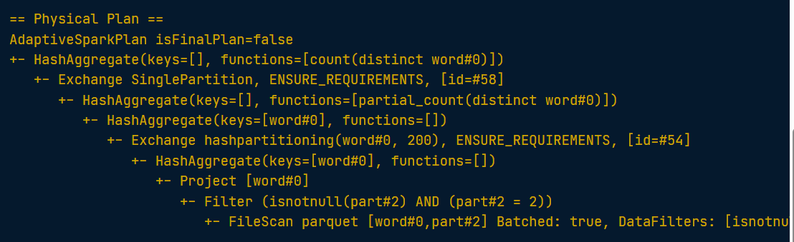

Practice reading query plans 2
Three dataframes are available: part2_df, part3_df, and part4_df. The questions posed in this exercise can be answered by inspecting the explain() output of each dataframe.
Note that Spark tags each column name with a descriptor, delimited by a # symbol. For example, word#0, id#1L, part#2, and title#3. For the purpose of this exercise, these descriptors can be ignored.
Question
- What file was part2_df loaded from? The full path is not wanted here, we want only the filename and its extension.
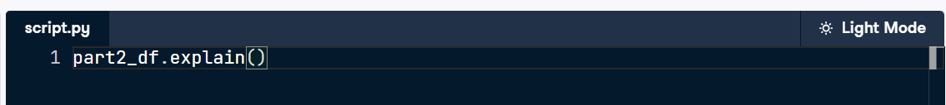
Answer: 'sherlock_parts.parquet'

Question
- part3_df has a bug. part3_df was supposedly loaded with column part = 3. Select the integer value that is actually loaded.
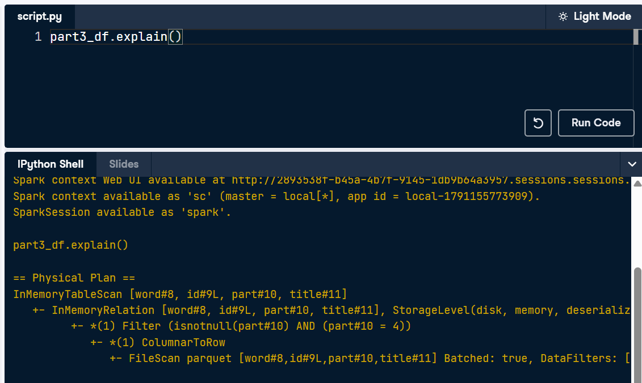
Answer: 4
Question
- What file was part4_df loaded from? The full path is not wanted here, we want only the filename and its extension.
Answer: 'sherlock.parquet'

Question
- The ReadSchema property tells us the schema of the dataframe that was loaded. Give the value of the ReadSchema property of part4_df.
Answer: 'struct<word:string,id:bigint>'

Chapter 4 – Text Classification
Practicing creating a UDF
Sometimes your data needs a transformation that is not supported by built-in functions. This is where a custom user defined function ("UDF") is suitable.
The SQL function udf is available. A dataframe df2 is available, of type
DataFrame[doc: array<string>, in: array<string>, out: array<string>]
. It's doc column contains trivial tokens.
The following displays the first 20 rows of df2 where doc contains '1':
df2.where(array_contains('doc','1')).show()
You have two objectives to fulfill:Ensure that the transformed data consists of nonempty vectors. A dataframe has a column that contains arrays of string, where each array has a single item. You'd like to transform this column to a string.
1. Create a udf that returns true if and only if the value is a nonempty vector, using numNonzeros() Create a udf that returns the first element of the array and returns its string representation.
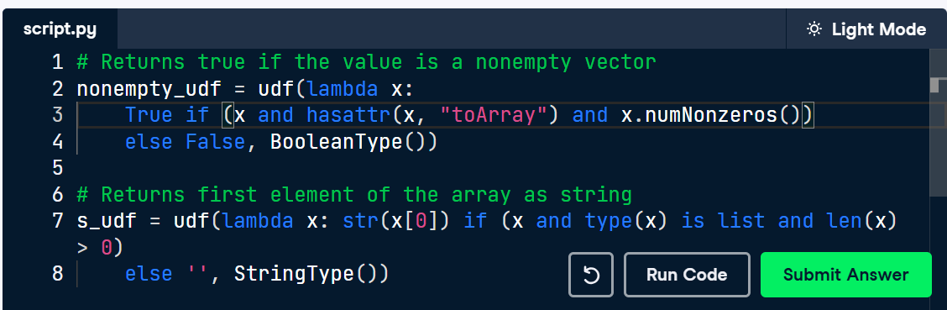
Practicing array column
The SQL function udf is available, as well as a dataframe df_before is available, of type DataFrame[doc: array<string>, in: array<string>, out: array<string>].
The TRIVIAL_TOKENS variable is a set. It contains certain words that we want to remove.
- Show the rows of df_before where doc contains the item 5.
- Create a udf that removes items in TRIVIAL_TOKENS from an array column. The order does not need to be preserved.
- Remove tokens from the in and out columns in df2 that appear in TRIVIAL_TOKENS.
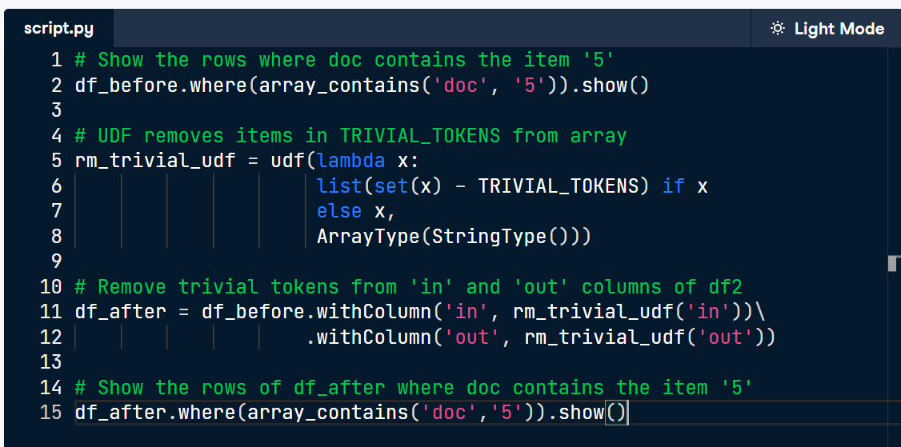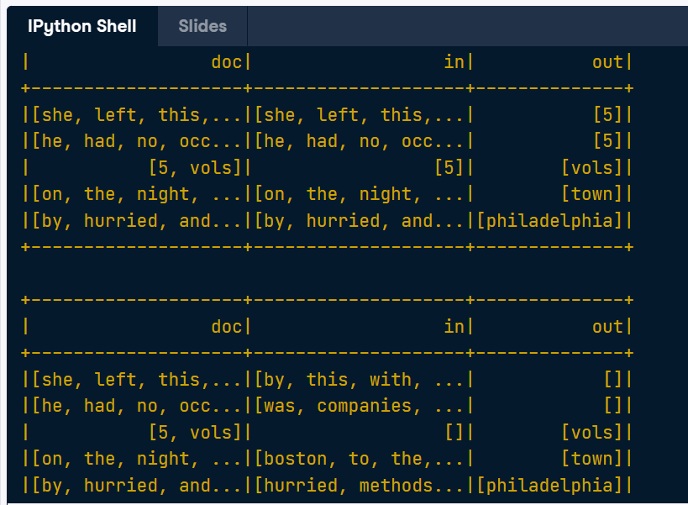

Creating a UDF for vector data
A dataframe df is available, having a column output of type vector. Its first five rows are shown in the console.
- Create a UDF called first_udf. It selects the first element of a vector column. Set the result to a default value of 0.0 for any item that is not a vector containing at least one item and cast the output as a float.
- Use the select operation on df to apply first_udf to the output column.}
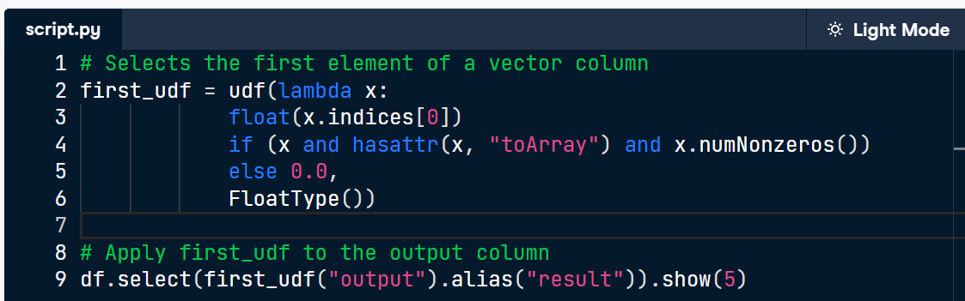
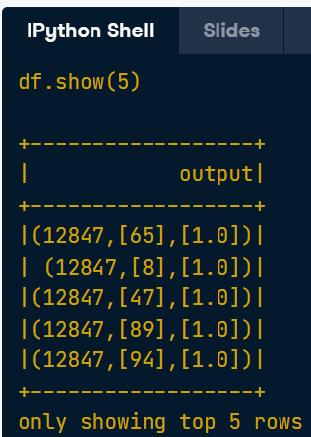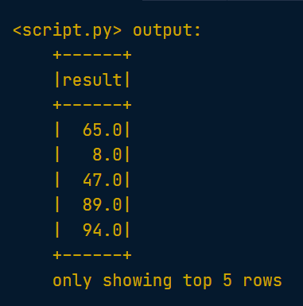
Nota solución: El detalle clave aquí es que esa estructura que ves en pantalla (12847,[65],[1.0]) no es una tupla de Python, aunque visualmente Spark la imprima con paréntesis para que sea fácil de leer.
En realidad, esa variable x es un objeto especial de Spark (específicamente de la clase SparseVector de la librería pyspark.ml.linalg).
Como es un objeto y no una tupla, no puedes acceder a sus partes por posición geométrica (x[0], x[1], x[2]). Tienes que acceder a sus datos llamando a sus atributos (propiedades) por su nombre usando la notación de punto (.):
- x.size (en lugar de x[0]) para obtener el tamaño.
- x.indices (en lugar de x[1]) para obtener el arreglo de posiciones.
- x.values (en lugar de x[2]) para obtener el arreglo de valores.
Es por esto que el código exige usar x.indices en lugar de simplemente x[1].

Applying a UDF to vector data
A dataframe is available called df having a column output of type vector. Its first five rows are shown in the console.
A UDF get_first_udf is available that selects the first element of a vector column.
1. Create a new dataframe called df_new by adding a new column to df. Call the new column label . Show the first five rows of df_new.
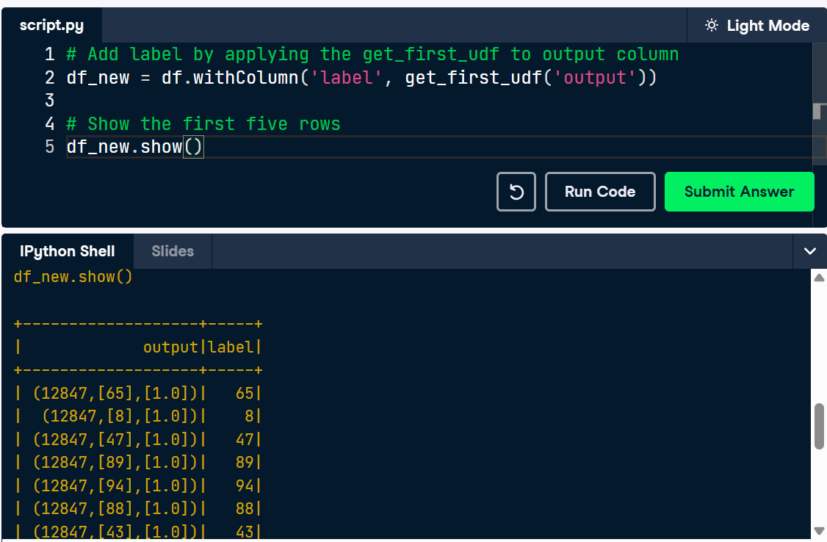

Transforming text to vector format
You learned how to split sentences and transform an array of words into a numerical vector using a CountVectorizer.
A dataframe df is provided having the following columns: sentence, in, and out. Each column is an array of strings. sentence is a list of words representing a sentence from a text book. The out column gives the last word of sentence. The in column is obtained by removing the last word from sentence.
The CountVectorizer model expects a dataframe having a column words and creates a column vec.
You will first perform a transform that adds an invec column, which looks like the following:
+----------------------+-------+------------------------------------+
|in |out |invec |
+----------------------+-------+------------------------------------+
|[then, how, many, are]|[there]|(126,[3,18,28,30],[1.0,1.0,1.0,1.0])|
|[how] |[many] |(126,[28],[1.0]) |
|[i, donot] |[know] |(126,[15,78],[1.0,1.0]) |
+----------------------+-------+------------------------------------+
only showing top 3 rows
Then you will perform a second transform, which looks like the following:
+------------------------------------+----------------+
|invec |outvec |
+------------------------------------+----------------+
|(126,[3,18,28,30],[1.0,1.0,1.0,1.0])|(126,[11],[1.0])|
|(126,[28],[1.0]) |(126,[18],[1.0])|
|(126,[15,78],[1.0,1.0]) |(126,[21],[1.0])|
+------------------------------------+----------------+
only showing top 3 rows

- Create a dataframe called result by using model to transform() df. result has the columns sentence, in, out, and invec. invec is the vector transformation of the in column.
- Add a column to result called outvec. result now has the columns sentence, in, out, invec, and outvec.
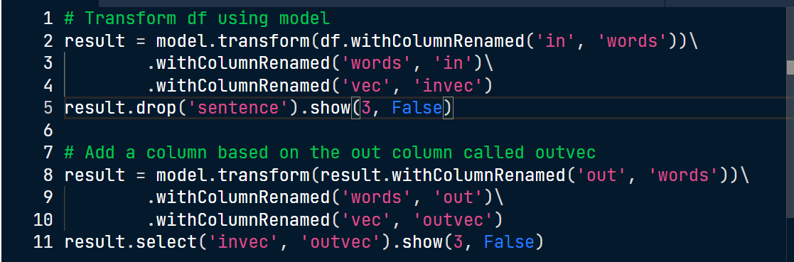
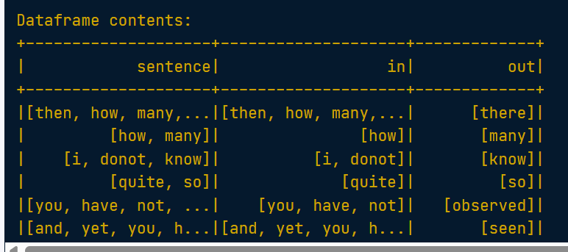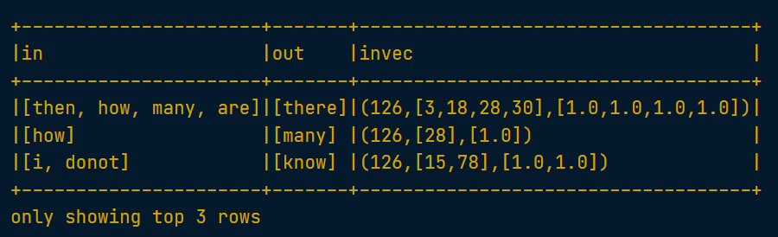
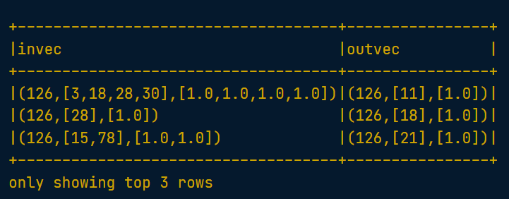

Label the data
A dataframe df is available having columns endword: string, features: vector, and outvec: vector. You are to select the rows where endword equals "him", and add a column label having the integer value 1. Then, use the union operation to add an equal number of rows having endword not equals to him, such that these additional rows have label = 0.
As a reminder, in SQL the not equals comparison is done using <>.
1. Import the lit function. Select the rows where endword is 'him' and add a integer column label having the value 1. Select the rows where endword is not 'him' and add a integer column label having the value 0. Union these two sets, using a number of negative examples equal to the number of positive examples.
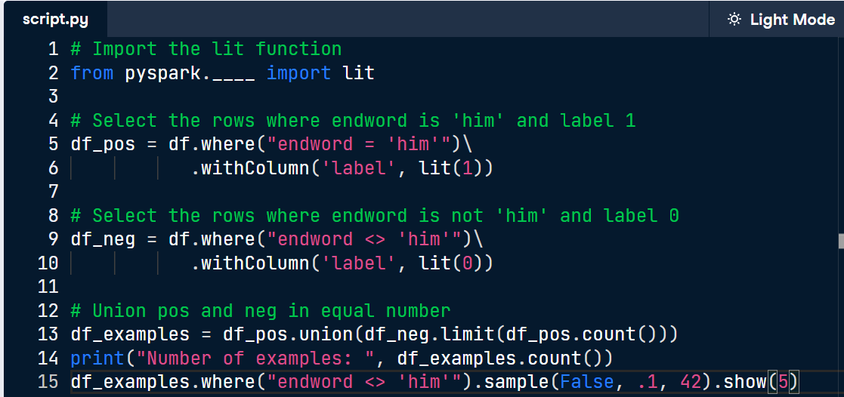
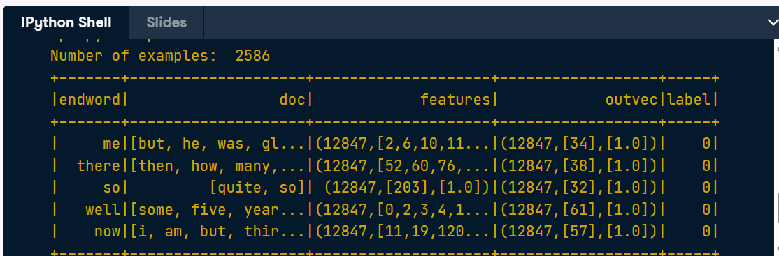
Split the data
A dataframe df_examples is available having columns endword: string, features: vector, outvec: vector, and label: int. You're going to split it to obtain training and testing set, which you will use to train and test a classifier.
1. Split the examples into train and test using a 80/20 split. Print the number of training examples. Print the number of test examples
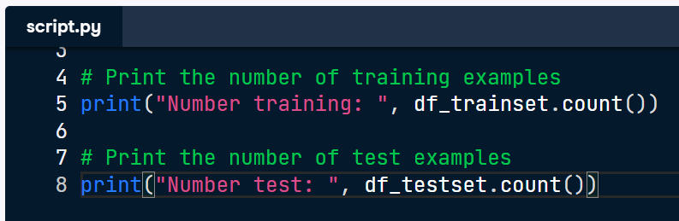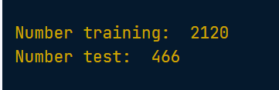
Train the classifier
The dataframe df_trainset you created in the previous exercise is available. You're now going to use it to train a Logistic Regression Classifier.
1. Import the Logistic Regression Classifier. Instantiate the classifier. Set maximum iterations to 100, the regularization parameter to 0.4, and the elastic net parameter to 0.0. Train the classifier on the trainset. Print the number of training iterations.
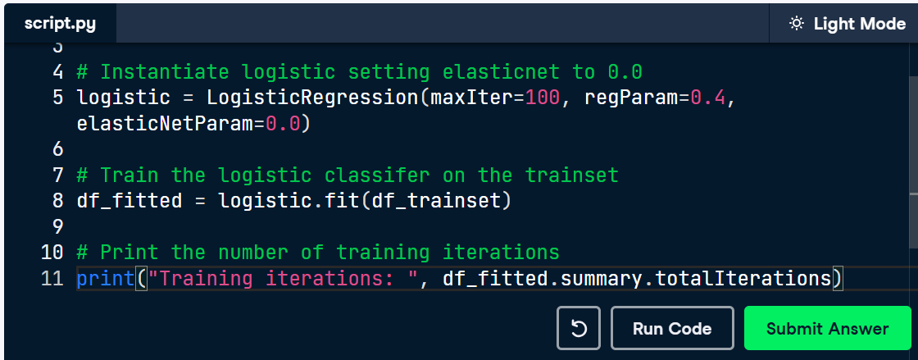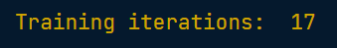

Evaluate the classifier
A trained logistic regression model df_fitted is available. A dataframe df_testset is available containing test data for this model.
1. Score the trained model on the test data. Print the Area Under Curve metric.
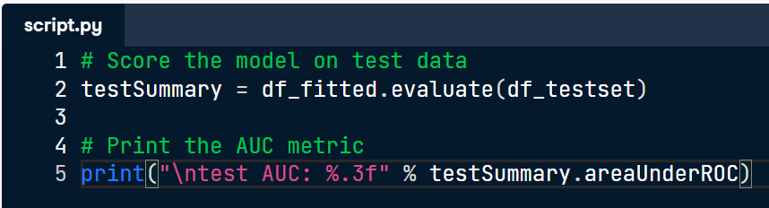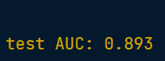
Predict test data
A fitted logistic model df_fitted is available. A dataframe df_testset is available containing test data for this model. A variable fields is available, containing the list ['prediction', 'label', 'endword', 'doc', 'probability']; this is used to specify which prediction fields to print.
1. Apply the model to the data in df_testset. Print "incorrect" if prediction does not match label.
